**Twitter Data**

* **Set 1** (Colin from “Beyond the hashtags” project): June 1, 2014 - May 31, 2015. 40,815,975 tweets contributed by 4,435,217 unique users. TWITTER PERIOD 3 / AUG 9 - AUG 31, 2014; 12,589,097 TWEETS; 1,734,541 UNIQUE USERS
  + Used 45 keywords (e.g. Ferguson) for content RE: Black Lives Matter and police killings of Black people under questionable circumstances (e.g., Eric Garner, 7/17/14; **Mike Brown 8/19/14 --** TWITTER PERIOD 3).
* **Set 2** (Courtney/World Well-Being Project): # Tweets? by # unique users?
  + Feb 2012 - Feb 2013 (year after Trayvon killed, 2/26/12)
  + July 2013 - July 2014 (year after acquittal of Zimmerman, 7/13/13)
  + Focuses on Trayvon Martin, keywords?
* Three important parallels across these time points:
  + Trayvon Martin murder (2/26/12) + non-indictment of Zimmerman (7/13/13)
  + Mike Brown murder (8/19/14) + non-indictment of officer (11/24/14)
  + Eric Garner murder (7/17/14) + non-indictment of officer (12/3/15)
* Interests:
  + Assessing ways different people responded to and talked about these events. This may include references to racial discrimination/injustice, stress, affect/emotion (sentiment), health (behaviors), politics (behaviors), movements (e.g., #BLM).
* Possible Analyses:
  + machine learning categorization of images (e.g., Mike Brown in street) and/or text and the surrounding context.
  + social network analysis of Tweeters & their influence, circulation of particular content over time, spread of sentiment,
  + natural language (e.g., sentiment) analysis of tweet content, may include references to racial discrimination/injustice, stress, affect/emotion (sentiment), health/health behaviors, politics/political behavior, movements (e.g., #BLM).

**Additional data -- news coverage:**

* National media coverage of police violence, 2006-2018, Top 4 media outlets (Courtney)
* Mainstream and Black online news re: Ferguson (Turetsky & Riddle, 2018 w/ Colin)

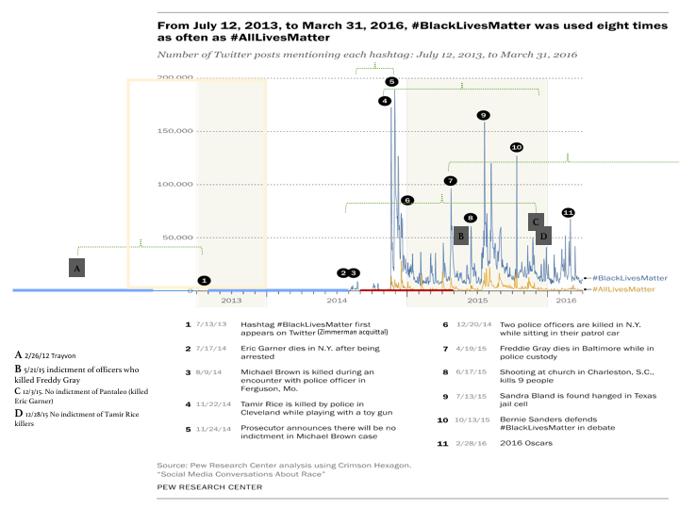



**Set 2 (Courtney/World Well-Being Project): 2012-14**

Number of Tweets, unique users?

Variables?

**Set 1** (Colin from “Beyond the hashtags” project)**: 2014-15**

We have Tweet IDs and can turn (“hydrate”) Tweet IDs into a Twitter JSON file with Hydrator software: <https://github.com/DocNow/hydrator>

Freelon et al. (2016) Beyond the Hashtags

Twitter data from Charlton McIwain

“We purchased directly from Twitter all public tweets posted during the yearlong period

between June 1, 2014 and May 31, 2015 containing at least one of 45 keywords related

to BLM and police killings of Black people under questionable circumstances (see Table 3).

The keywords consist mostly of the full and hashtagged names of 20 Black individuals killed

by police in 2014 and 2015. We counted a tweet as including a particular name if it contained

either the case-insensitive full name or hashtagged name as written below. The resulting

dataset contains 40,815,975 tweets contributed by 4,435,217 unique users.

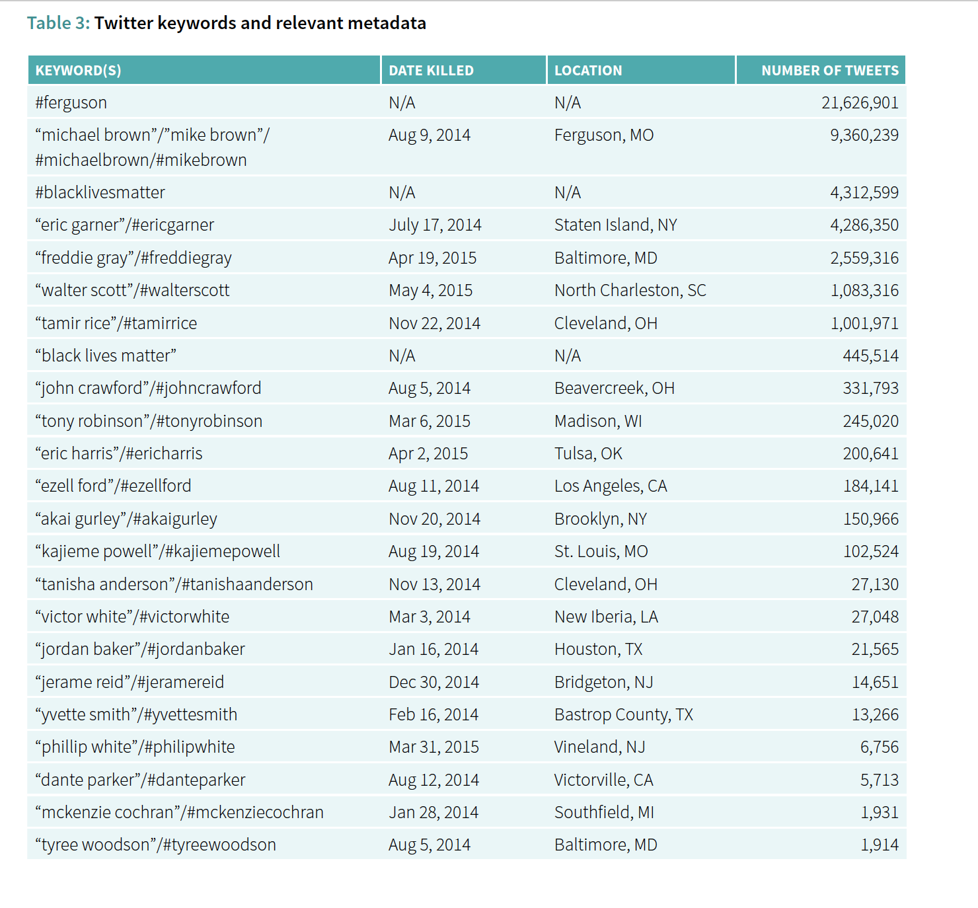

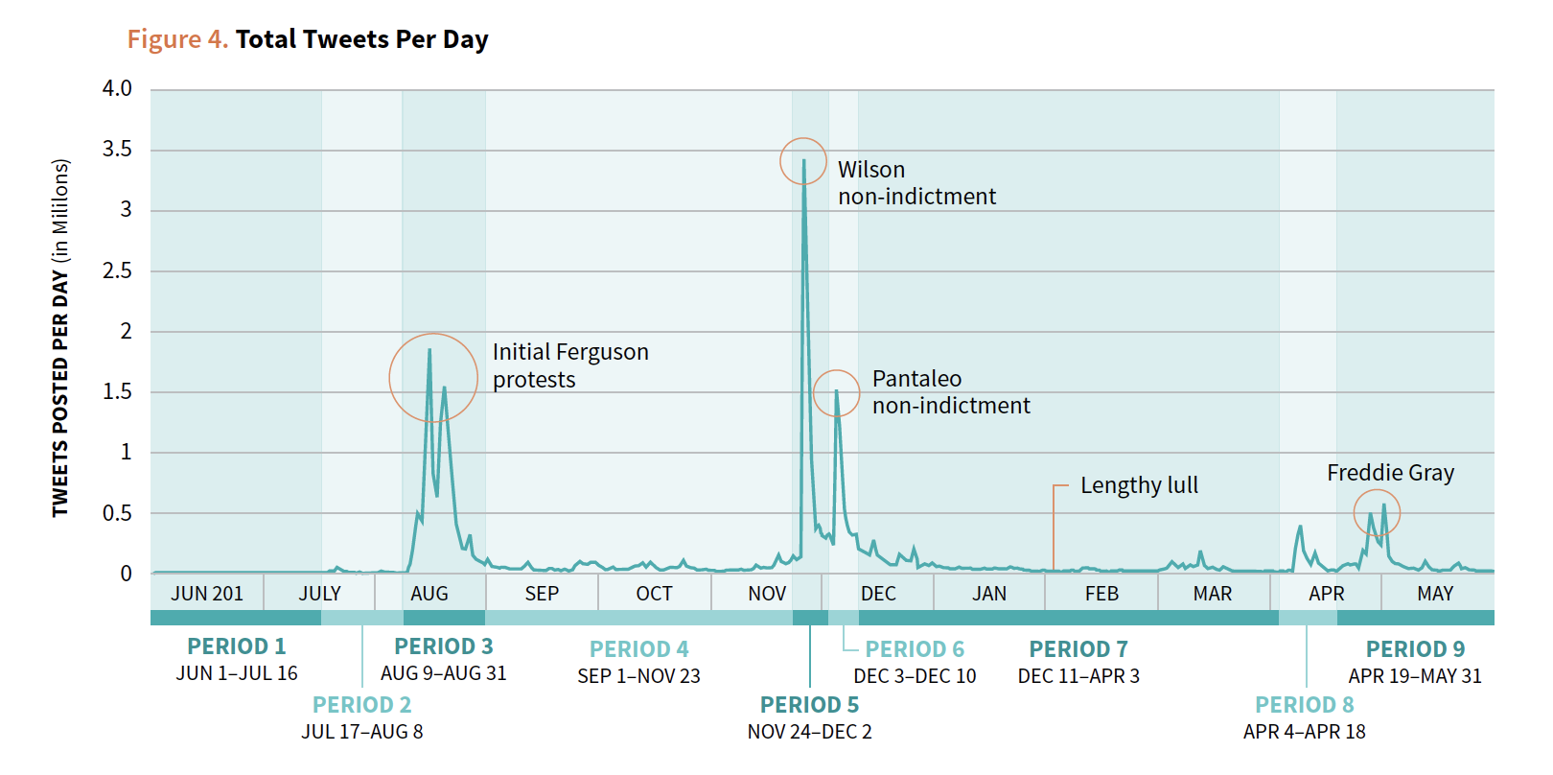

TWITTER PERIOD 3 / AUG 9 - AUG 31, 2014

12,589,097 TWEETS, 1,734,541 UNIQUE USERS



TWITTER PERIOD 4 / SEP 1 - NOV 23, 2014

4,609,046 TWEETS; 663,887 UNIQUE USERS

TWITTER PERIOD 5 / NOV 24 - DEC 2, 2014

8,528,144 TWEETS; 1,966,447 UNIQUE USERS

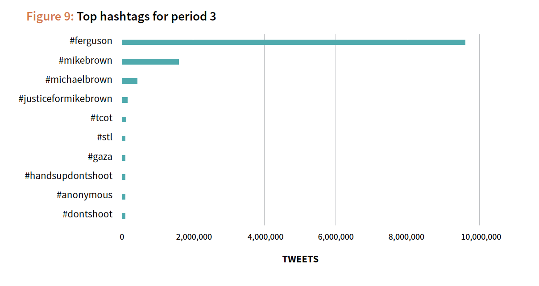

Darren Wilson killed Michael Brown shortly after noon CST on August 9, 2014. The first tweet

in our dataset to reference the shooting appeared at 3:13pm CST and retweeted Grant Bissell,

a reporter for the St. Louis-based local TV station KSDK. Bissell’s tweet, which he posted

at 3:05 pm, gave a straightforward account of the scene and featured a photo of a small

gathering of Black residents at the scene of the shooting:

SCREEN NAME / COMMUNITY / LINK

@gbissellksdk / MULTIRACIAL LEFT 1

<https://twitter.com/gbissellKSDK/status/498198378044743680>

We cannot be sure that this was the first reference to the shooting on Twitter, as earlier

tweets may have done so without using our keywords. But it was almost certainly one of the

first, and at that point in time we can say definitively that Brown had not been identified by

name on Twitter.

The first individual to mention Brown’s name after his death is a 20-something Black male

resident of St. Louis whose tweet read simply, “RIP Mike Brown.”

Three individuals played an outsized role in spreading the word about Brown’s death far

beyond the St. Louis area that evening: St. Louis-based rapper Tef Poe (@tefpoe); Michael

Skolnik (@michaelskolnik), a New York City-based entrepreneur and activist; and Shaun King

(@shaunking), an Atlanta-based activist and writer for the New York Daily News. At 6:42pm

CST, Poe posted a chilling photo of Brown’s dead body lying in the street:31

@tefpoe / MULTIRACIAL LEFT 1

<https://twitter.com/TefPoe/status/498253074566483968>

The national media picked up the story within a few hours. The first national outlet to appear in our data is News One, which ran an AP story at 7:31 pm headlined *“Ferguson, Missouri Crowd After Fatal Shooting Of Unarmed Teen: ‘Kill The Police’.”* We collect links to this and the other early Ferguson news stories by the national mainstream press in Table 5.

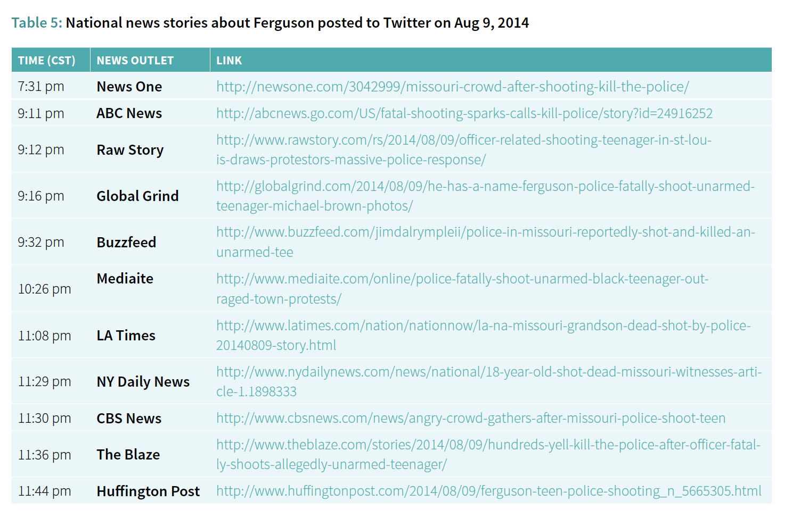

Despite this early national media coverage, the initial Twitter conversations that referenced

our keywords were led by Skolnik, King, French, and other activists. Links to national news

stories were shared far less than commentary, photos, and information from these activist

sources.

Tweet volume peaked between August 13 and 14, likely driven by a combination of the following factors:

»» Police attacks on and/or detention of several prominent information sources, including

Wesley Lowery of the Washington Post, Ryan Reilly of the Huffington Post, Antonio

French, and an al-Jazeera television crew;

»» Dramatic photos of tear gas diffusing through the crowd that were widely shared;

»» The gradual increase in global interest in the story, driven by the first two factors; and

»» A marked uptick in the number of highly-visible accounts (specifically those with over

100,000 followers) sharing information about the protests.

Figure 8 displays the 10 largest network discussion communities in TWITTER PERIOD 3, offering a sense of the various kinds of individuals who took an interest in Ferguson.

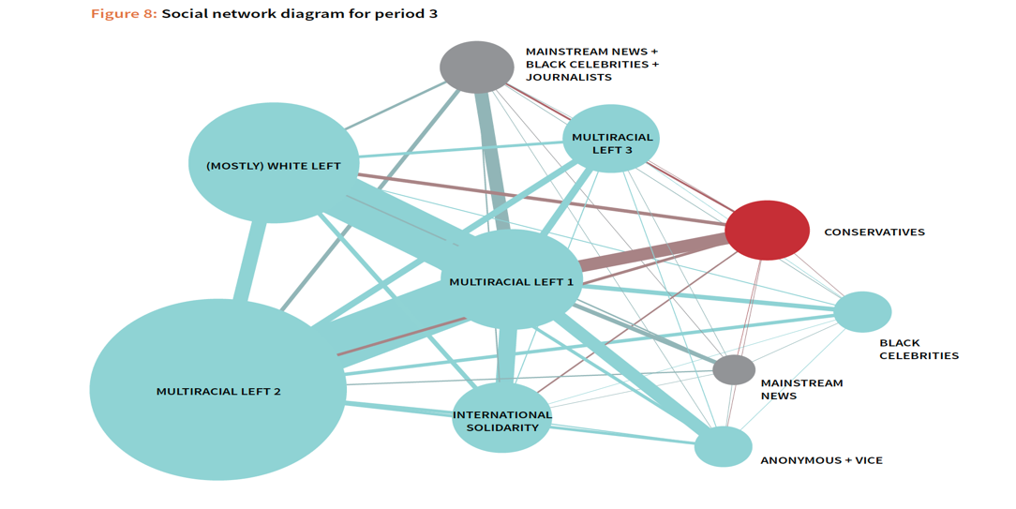

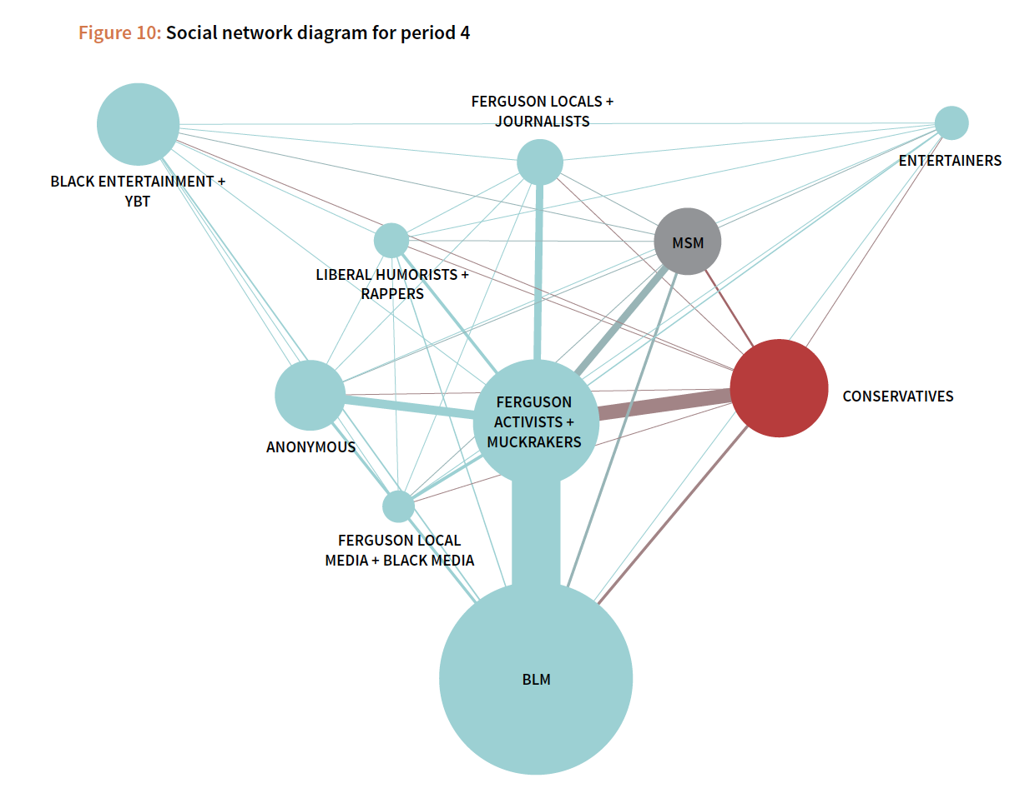

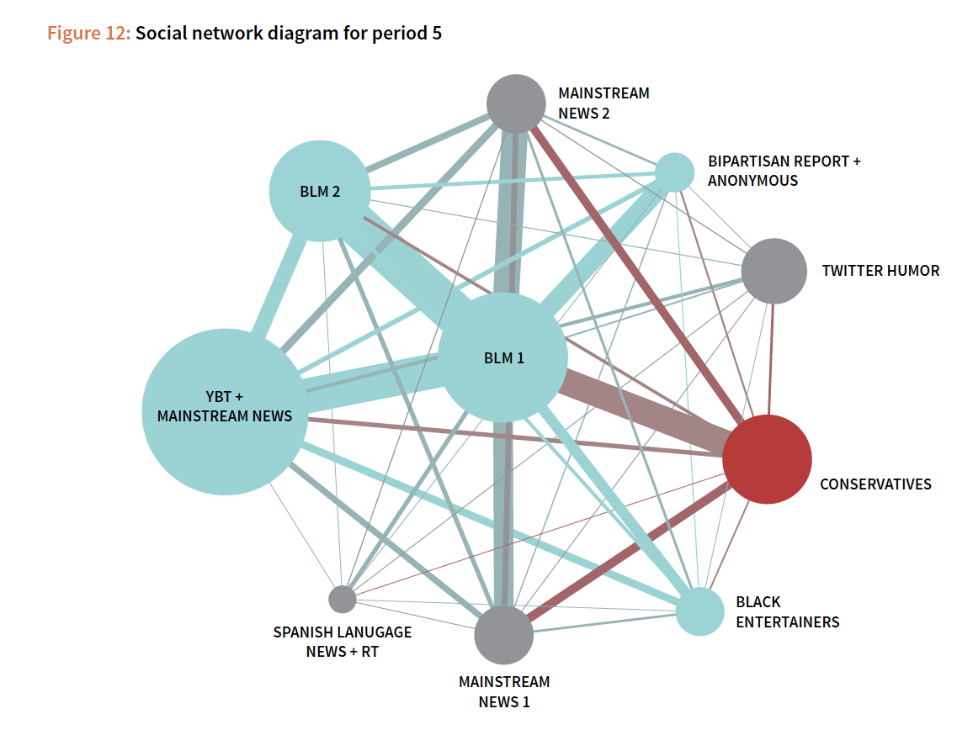

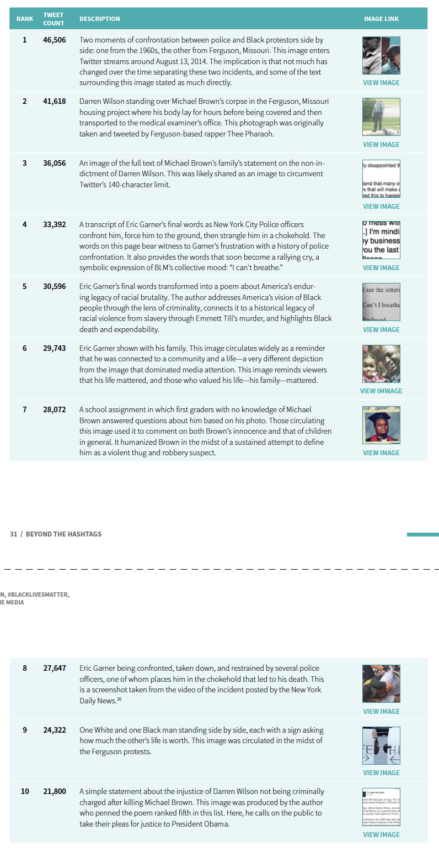

We may be able to combine the Tweets from Aug 2014 in this database with Turetsky and Riddle’s (2018) dataset of online news coverage in the 10 days after Mike Brown was killed.

Articles about the Ferguson shooting were collected from the top overall 51 online media sources and top 18 African American– oriented online media sources, identified by Pew Research Center (2015) based on number of unique visitors in January, 2015. Using the search engines of sources’ websites and Google search functions, we obtained all articles containing the key word “Ferguson” published by these sources in the 10 days after Michael Brown was shot, August 9–19, 2014. This date range was strategically selected to correspond with the initial period

of protest in Ferguson.

After accounting for overlap in these sources and sites without any relevant articles, our final sample included 3,284 articles from 66 online news sources.

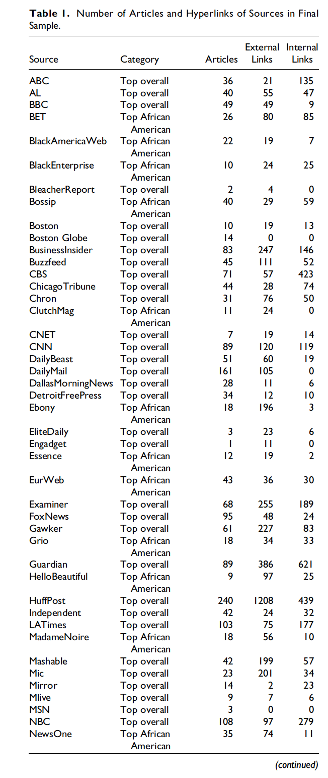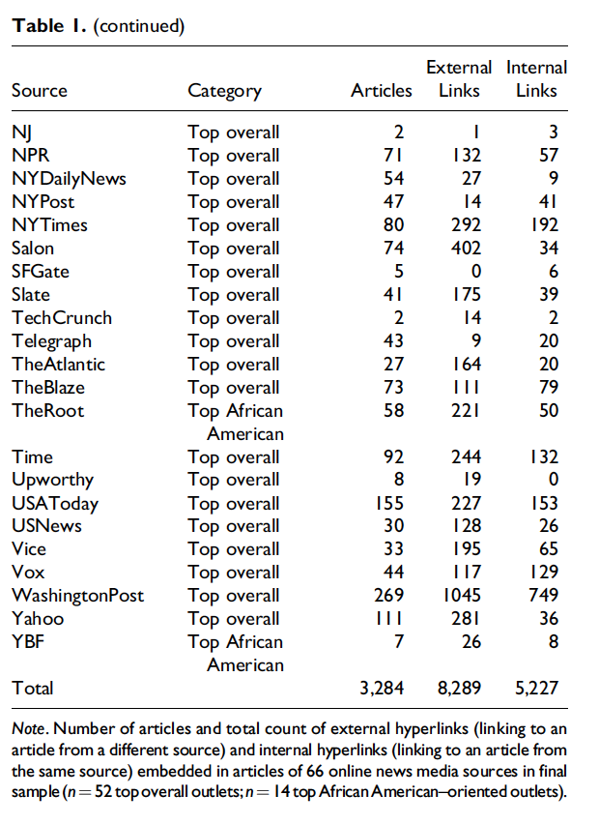

Figure 2. The subnetwork of 64 sources for which political leaning data were available, colored by proportion of conservative users from red (highest proportion of conservative users) to blue (lowest proportion of conservative users). Internal hyperlinks (an article linking to another article from the same source) are not pictured, nor are hyperlinks from or to sources outside the 64-source subset.